11430495
CCTV expenditure by class and rural/urban divide
Introduction
In this blog I will be answering the question ‘how is household expenditure on CCTV security systems impacted by class and the rural/urban divide in India?’. I will be doing this by analysing data from the national sample survey ‘Household expenditure on services and durable goods -July 2014 – June 2015’ 72nd round. My chosen variables for this analysis are MPCE (mean per capita expenditure), CCTV sales and rurality. I chose these variables as previous literature has shown that there are large wealth disparities between rural and urban demographics in India (Anand 2023). However, 12% of the world population resides in the Indian rural market and a greater understanding of this segment is needed for businesses to effectively tap into it (Parida and Sahney 2017). I will begin this blog with a presentation of two statistical graphs followed by a short discussion of the findings and limitations of the research.
Graph 1
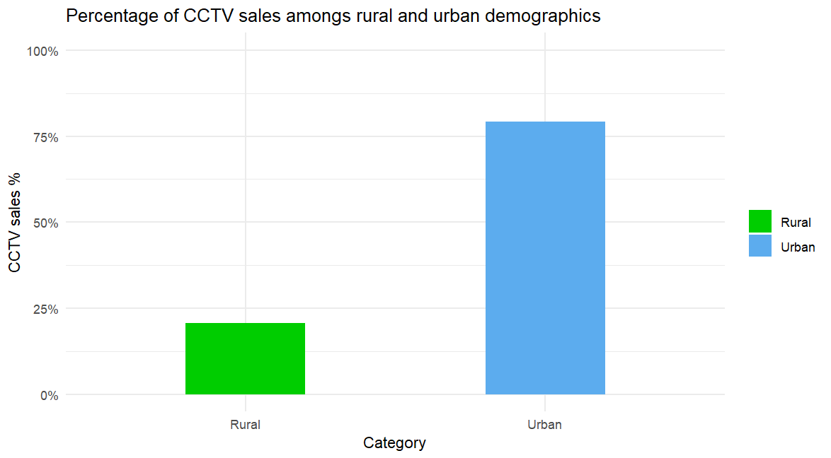
Figure 1
Figure 1 shows the percentage make up of CCTV and security expenditure among rural and urban demographics in India based on the household expenditure data set. Urban households make up 80% of all CCTV expenditure whereas rural households only make up 20% of the market share. One clear reason for this disparity as identified by Anand et al (2023) is that buildings make up a much greater proportion of urban demographics assets at over 44.8% in 2012 compared to 21% in rural demographics. This would mean that rural demographics have less need for expenditure on security systems as compared to urban demographics.
Graph 2
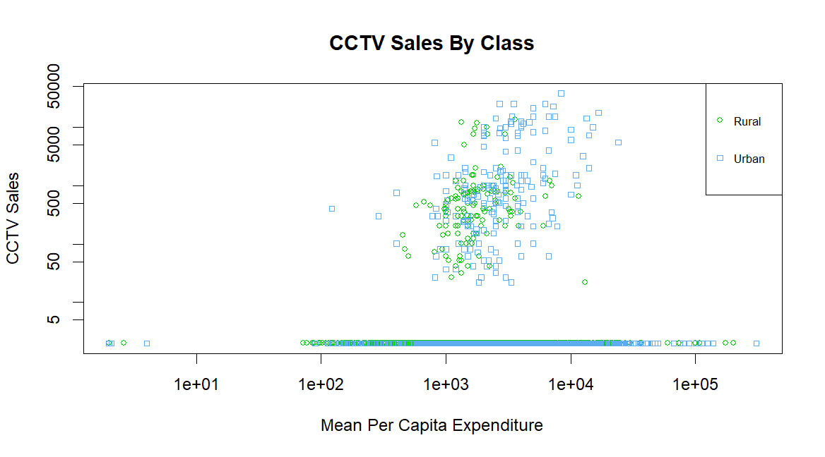
Figure 2
Figure 2 shows the levels of CCTV expenditure against mean per capita expenditure whilst also accounting for rural and urban demographics. MPCE is used to account for class as higher levels of spending indicate higher levels of wealth. Many of the plots fell on 0 expenditure so the plot had to be placed on a logarithmic scale in order to clearly identify points. This graph shows there is an observable positive correlation between higher mean per capita expenditure, CCTV expenditure and urban demographics. Research from Anand (2023) supports this showing that even rural households with high levels of expenditure pale in comparison to the wealthiest of urban households.
Limitations
However, there are some limitations of the data set and research I have conducted. One limitation is that the data is approaching 10 years in age and may no longer be as relevant to market analysts as India is rapidly developing. Furthermore, the limited scale and reach of my analysis means it fails to capture other socioeconomic factors affecting CCTV expenditure nor does it account for differences between states and regions within India rather taking a holistic approach.
Conclusion
Despite its limitations this analysis has shown that wealthy urban households dominate the market for CCTV and security products in India due to large wealth disparities between the demographics. However, if businesses wish to tap into the rural security market a more up to date and specific research is required.
Bibliography
- Anand, I., Thampi, A., Vakulabharanam, V. (2023). ‘Wealth inequality: the Indian case’, Canadian Journal of Development Studies, DOI: 10.1080/02255189.2023.2212898
- National Sample Survey Office, MOSPI, Government of India, (2016). ‘Household expenditure on Services and Durable goods’. Available at: India - Household expenditure on Services and Durable goods - JULY 2014 - JUNE 2015, 72 round
- Parida, R. R., Sahney, S., (2017). ‘Exploration of Indian rural markets and marketing’, Asia Pacific Journal of Marketing and Logistics, 30 (2), pp. 297-308. DOI 10.1108/APJML-12-2016-0241

